**INTRODUCTION**

The online food ordering system is a user-friendly platform designed to streamline the process of ordering food. With the increasing demand for convenience and efficiency in today's fast-paced lifestyle, this system bridges the gap between customers and food stores, allowing them to interact seamlessly. Users can browse menus, select dishes, and place orders directly through the website , eliminating the need for physical visits or phone calls. This digital transformation ensures a more personalized and efficient dining experience.

One of the core objectives of this system is to enhance customer satisfaction by providing a hassle-free ordering process. The system allows users to explore a variety of fast-food based on preferences, or choices. Additionally, it ensures accurate order placement, reducing human errors often associated with manual processes. benefit from an organized order management system that improves operational efficiency

The system integrates features such as secure payment gateways and user system also promotes digitalization and sustainability by reducing the need for printed menus and receipts. Customers can enjoy their favorite meals at the click of a button

In conclusion, the online food ordering system is a versatile and innovative solution for modern food service needs. It benefits customers by saving time and offering convenience while empowering to deliver better services and increase profitability. This system exemplifies how technology can transform traditional business models into efficient, customer-centric platforms.

login for security concerns. These functionalities not only provide convenience but also build trust and loyalty among users. User friendly design , further enhance the user experience, making it a preferred choice for modern consumers.

**EXISTING SYSTEM**

These platforms allow customers to browse menus, place orders, and make payments online. However, restaurants often face high commission fees and limited control over their branding and customer interactions.

The orders section lets users to choose their favorite dishes. The contact submissions section helps manage customer inquiries, while the feedback section allows customers to share their experiences.

The dashboard is divided into several sections, including orders, contact submissions, and feedback submissions, each with its own unique features and functionality.

Overall, while online food ordering is widely available, many existing systems lack flexibility, security, and efficiency. A dedicated, well-optimized online food ordering system can improve restaurant operations, reduce dependency on third-party apps, and provide a seamless customer experience.

**NEED AND SCOPE**

**Need:**

With increasing demand for convenience, customers prefer online food ordering over traditional methods. Phone calls and walk-ins are time-consuming and error-prone. A dedicated system ensures a faster and smoother process.

Restaurants need an efficient system to manage orders, reduce errors, and handle peak hours. Automation improves efficiency, enhances customer satisfaction, and eases staff workload.

Digital payments and contactless delivery have made online ordering essential. A secure and user-friendly system ensures smooth transactions and boosts customer trust, helping businesses grow.

**Scope:**

The FoodHub project aims to provide a comprehensive platform that streamlines the food ordering process while enhancing user engagement through features like dish suggestions, feedback collection, and contact management.

The system allows users to easily place orders, suggest new dishes, provide feedback, and register seamlessly. It also provides an intuitive admin dashboard where administrators can manage orders, view user suggestions, analyze feedback, and respond to customer queries.

This system is scalable and can be further extended to include features such as online payment integration,and personalized recommendations based on user preferences. With a user-friendly interface and efficient backend management, FoodHub ensures a smoother experience.

**ORGANIZATION PROFILE**

**INTRODUCTION :**

FoodHub is a dynamic food ordering service that was founded 10 years ago by Mr. Ram Patil in Belgaum, India. Initially operating as an offline fast food ordering service, FoodHub quickly gained popularity due to its quick service and diverse menu offerings. Recognizing the evolving market trends and the growing demand for online services, the founder took a strategic step to digitize the business by launching a user-friendly web application.

Today, FoodHub stands as a reliable online food ordering platform in India, offering a wide range of fast food items and meal combos through a single, easy-to-navigate website. The platform aims to provide a seamless and convenient ordering experience for customers, combining speed, variety, and customer satisfaction at its core. With its digital transformation, FoodHub continues to grow and adapt, embracing technology to meet modern customer expectations and enhance service delivery

**Proposed System**

* A proposed system for a food ordering , FoodHub could include the following key features:
* Provides a user-friendly online platform for customers to browse, select, and order food easily.
* Allows users to create accounts, login securely.
* Facilitates a seamless food ordering system where users can choose items, customize orders, and place them in real-time.
* Includes an admin dashboard to manage orders, view feedback, handle contact submissions, and monitor registered users.
* Provides a dedicated "Your Taste" feature where customers can suggest new dishes to improve customer engagement.
* Supports contact and feedback forms for users to communicate their issues or suggestions.
* Ensures data validation and secure backend integration using Node.js and MySQL.
* Enables the admin to view and manage customer suggestions, feedback, and user details in one central location.
* Aims to provide a faster, more efficient alternative to the traditional offline food ordering process

**Objective**

* Provide a centralized food ordering platform where users can browse a variety of fast food options from multiple vendors.
* Enhance user convenience by offering a smooth ordering experience with secure payments.
* Ensure data security by protecting user information.
* Improve vendor accessibility by enabling multiple food vendors to list their products and manage their menus easily.
* Enable feedback and support by allowing users to review orders, rate vendors, and get customer assistance.
* Expand market reach by connecting food vendors with a wider audience through an online ordering system.

**Requirement Gathering**

Requirement Gathering is the process of generating a list of functional, technical and systematic requirements from several projects take holders, such as clients, IT staff, product users or vendors. This list may likely, include features, activities and tasks for a team to execute in order to achieve the goals of a project. Usually, there are two types of requirements to consider: functional and non-functional. Functional requirements include the information, interactions and processes that a client requests. Non-functional requirements are other technical and operational aspects of a project.

Consider starting the process of requirements gathering at the beginning of a project to help ensure effective planning and management. Here are some aspects to consider as you start requirements gathering:

**Timeline:**

This entails estimating the overall length and schedule of a project. This can help you effectively plan for its requirements over the course of an entire project, ensuring that you’re prepared throughout its duration.

**People:**

Consider who you want to include in a project and what their various roles might be. Try to determine their individual requirements, as well a show they might collaborate with the entire team.

**Goals:**

Identifying primary goals early can help you determine a project’s requirements and ensure that the project specifically focuses on executing these objectives

**Fact Finding Techniques**

In order to gather analyze the relevant information following method or adopted.

**1) Observation:-**

Find hand information about various activities carried out can be studied through observation. This method used to solve how documents where handled, how processes where carried out and whether those stapes when actually followed thus current scenario was understood using observation.

**2) Record Review:-**

The study of records maintained to give clear idea as to how actual process carried also management working on whole.

**3) Document Searching:-**

Various documents which are handled these used formats where studied relation with system, information analyzed.

**Requirement Analysis**

Requirement analysis is a software engineering task that bridges the gap between system level requirements engineering & software design. Requirement engineering activities results in the specification of software's operational characteristics include software's interface with other system elements, and establish constraints that software must meet. Requirement analysis provides the software designer with representation of information, function, & behavior that can be translated to data, architectural, interface & component-level designs. Finally the requirement specification provides the developer & the customer with the means to access quality ones software.

**Software requirement analysis may be divided into five area of efforts :**

* Problem recognition
* Evaluation & synthesis
* Modeling
* Specification
* Review

Initially, the analyst studies the systems specification & the software project plan. It is important to understand software in a system context & to review the software the software scope that was used to generate planning estimate. Next communication for analysis must be established so that the problem recognition is ensured. The goal is recognition of the basic problem elements as perceived by customers or user.

Problem evaluation & solution synthesis is the next major area of effort for analysis. The analyst must all externally observable data objects, evaluate the flow & content of information, define & elaborate all software functions, understand software behavior in the context of events that affects the system, establish system interface characteristics, & uncover additional design constraints.

**Feasibility Study**

**• Technical Feasibility:**

At first it's necessary to check that the proposed system is technically feasible or not & to determine the technology and skill necessary to carry out the project If they are not available then find out the solution to obtain them. Hardware is already available in the collage

* **Social Feasibility:**

Although generally there is always resistance, initially to any change in the system is aimed at reliving the work load of the user to extent the system is going to facilitate user to perform operation like calculating salary amount and deduction, generation reports with less possible error.

**Platform Selection**

We have developed **FoodHub**, an online food ordering system, using **HTML, CSS, and JavaScript** for the front end and **(Node.js)** with Express.js , Xampp server as the back-end database. These technologies ensure a responsive user interface and efficient data management for seamless order processing.

A **database** is a structured collection of related data, while a **database management system (DBMS)** is software that enables users to create, store, and manage data efficiently. MySQL is used as the DBMS for **FoodHub** to handle user accounts, orders, payments, and vendor details.

A database allows defining, constructing, and manipulating data. **Defining** involves structuring the database, **constructing** stores the data, and **manipulating** enables retrieving and updating records as needed.

To design and maintain an efficient database, we must:

* Identify relevant data for the food ordering system.
* Define specific attributes like orders, customers, and vendors.
* Establish relationships between objects such as users, orders, and payments.

The designed database ensures efficient data storage, quick retrieval, and smooth operation of **FoodHub**, making online food ordering hassle-free.

**Characteristics of Database Management System:**

* It keeps complex relation between data.
* Keeps a tight control of data redundancy
* Enforces user defined rules to insure the integrity of table data
* Ensures that data can be shared across applications
* Enforces data access authorization
* **Front End Tool [visual Studio IDE 2024-25]:**
* Visual Studio is a powerful developer tool that you can use to complete the entire development cycle in one place. It is a comprehensive integrated development environment (IDE) that you can use to write, edit, debug, and build code, and then deploy your app. beyond code editing and debugging, Visual Studio includes compilers, code completion tools, source control, extensions, and many more features to enhance every stage of the software development process.
* With the variety of features and languages support in Visual Studio, you can grow from writing your first "Hello World" program to developing and deploying apps. For example, build, debug, and test .NET and C++ apps, edit ASP.NET pages in the web designer view, develop cross-platform mobile and desktop apps with .NET, or build responsive Web UIs in C#.
* **Backend- MySQL:**

MySQL is an open-source relational database management system (RDBMS) that uses Structured Query Language (SQL) for managing and accessing data. The name “MySQL” combines “My” (the name of co-founder Michael Widenius’s daughter) and “SQL.” It organizes information into structured tables and supports relationships among them to efficiently handle large sets of data.

As an RDBMS, MySQL works closely with the operating system to store, retrieve, and manage data. It also offers features for data security, user access control, data integrity checks, and backup support. Developers use SQL commands to create, update, and retrieve data, making MySQL highly suitable for web-based and enterprise-level applications.

MySQL is available under the GNU General Public License as well as commercial licenses. Originally developed by MySQL AB (a Swedish company), it was later acquired by Sun Microsystems, and eventually by Oracle Corporation. After Oracle’s acquisition, the original developers created MariaDB, a fork of MySQL, to maintain its open-source nature.

MySQL is an integral part of the LAMP stack—Linux, Apache, MySQL, and PHP/Perl/Python—used widely in web development. It is compatible with many programming languages and frameworks, making it a reliable choice for developers building dynamic and scalable applications.

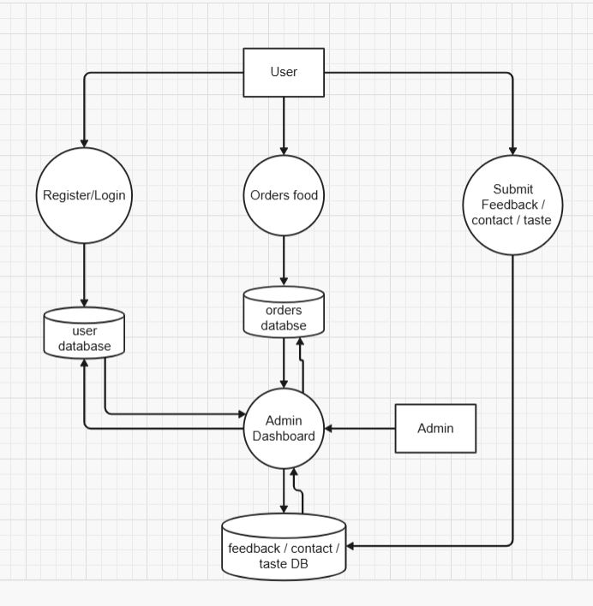**DFD**

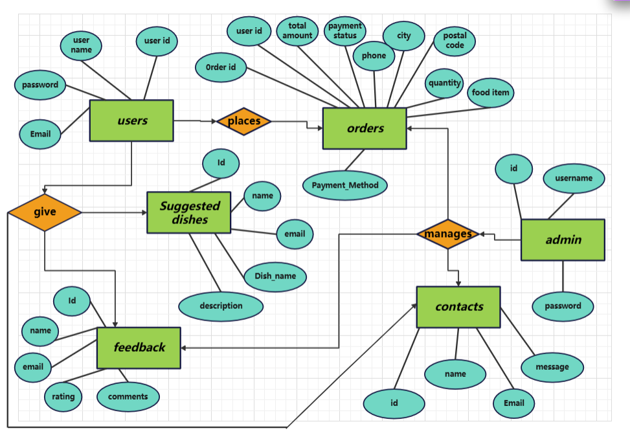**ERD**

**Software Testing**

**System Testing**

Testing presents an interesting anomaly for the software engineer during earlier software activities, the engineer attempts to build software from an abstract concept to a tangible product. The engineer creates a serial of test cases that are intended to "demolish" the software that has been built testing is conducted at various level of project

**Module Testing**

After doing unit testing, whole system is tested whether it is working properly or not. The screen together works as per requirement without effecting working of controls. In this we made sure that all the fields that should not be left blank or little by end-user or not.

**Integrated System Testing**

**Validation Testing:-**

At the culmination of integration testing, software is completely assembled as a package, interfacing errors have been uncovered and corrected and a final series of software tests-validation testing-may begin. Validation succeeds when software function in a manner that can be reasonable expected by the customer

**System Testing:-**

Software is incorporated with other system element (i.e. Hardware, People, information) and a series of system integration and validation tests are not conducted solely by software engineers. However, steps taken during software design and testing can greatly improve the probability of successful integration in the larger system

**SYSTEM REQUIREMENTS**

* **HARDWARE REQUIREMENT :**

**The For Client/User System:**

* Processor: Intel Core i3 or above
* RAM: Minimum 4 GB
* Hard Disk: At least 250 GB
* Display: 1024x768 resolution or higher
* Input Devices: Keyboard and Mouse
* Internet Connection: Required for online access

**For Server System (Development/Hosting):**

* Processor: Intel Core i5 or higher
* RAM: Minimum 8 GB
* Hard Disk: At least 500 GB
* Internet: High-speed connection for handling multiple requests
* Other: Backup power source recommended (UPS)
* **SOFTWARE REQUIREMENT :**

**Frontend Technologies:**

* HTML5, CSS3, JavaScript
* Web Browser: Google Chrome, Mozilla Firefox, or Microsoft Edge

**Backend Technologies:**

* Node.js (Express framework)
* Database: MySQL 8.0 CE
* Validation Library: Joi (for input validation)

**Development Tools:**

* Visual Studio Code or any preferred code editor
* XAMPP / MySQL Workbench (For managing MySQL database)
* Postman (For API testing)
* Git (For version control, optional)

**Operating System:**

* Windows 10/11, Linux, or macOS

**Admin**

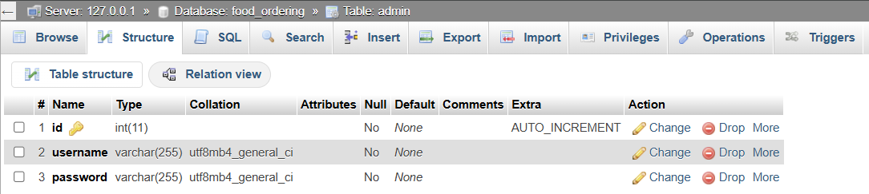

**Users**

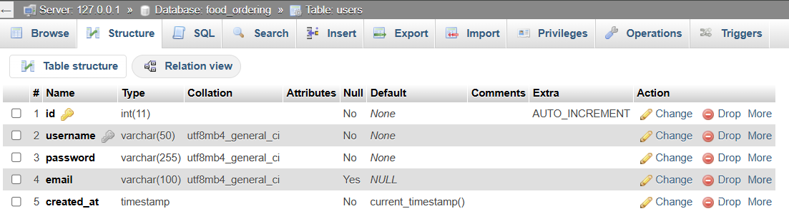

**Contacts**

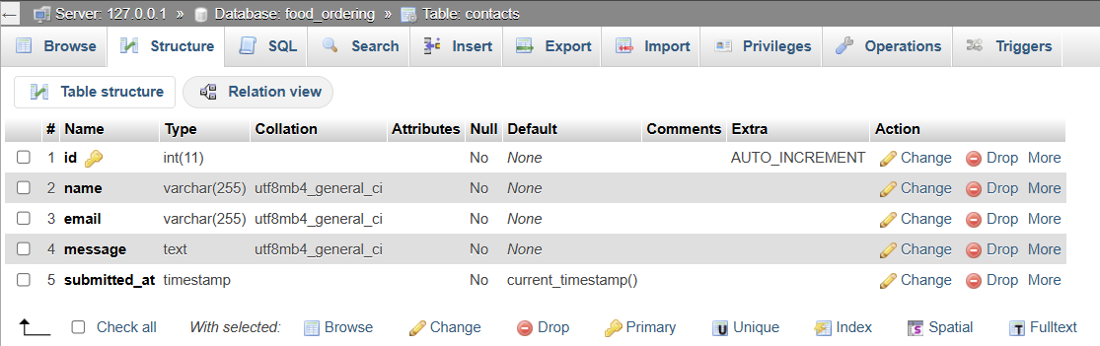

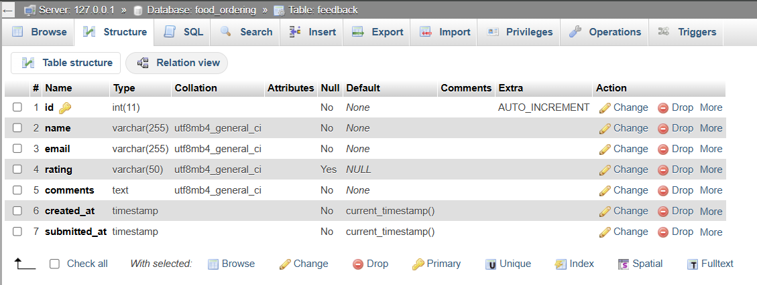

**Feedback**

**Orders**

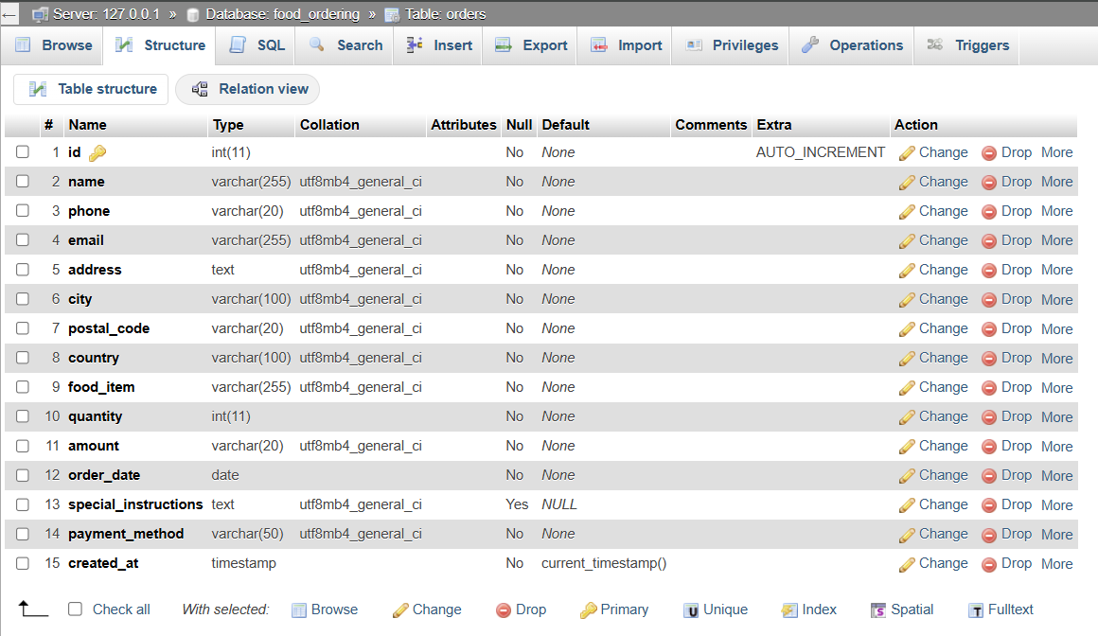

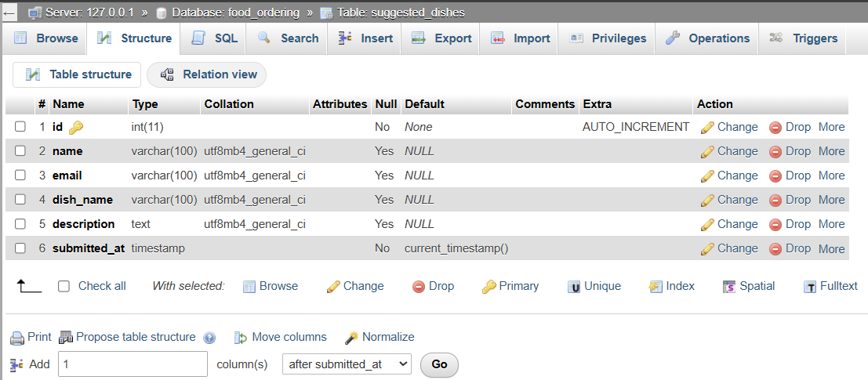

**Suggested Dishes**

**Home**

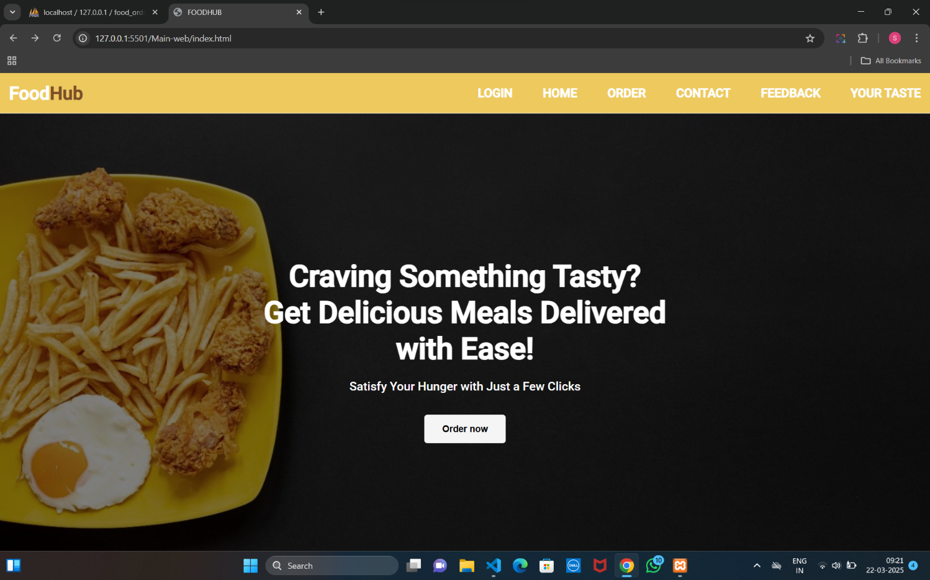

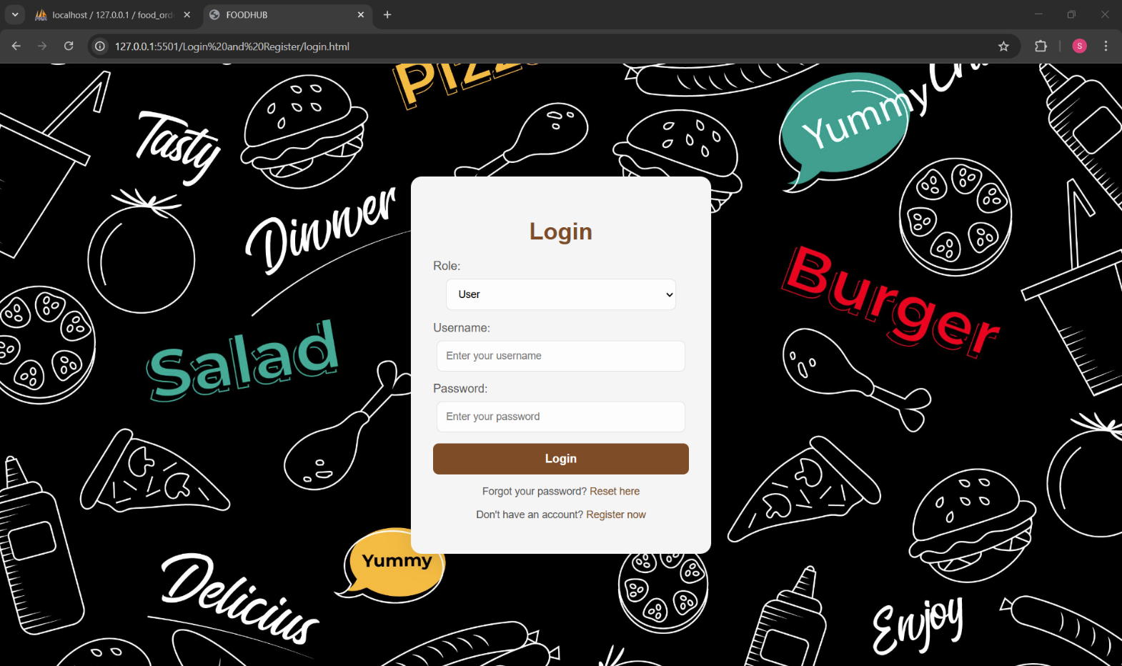

**Login**

**Register**

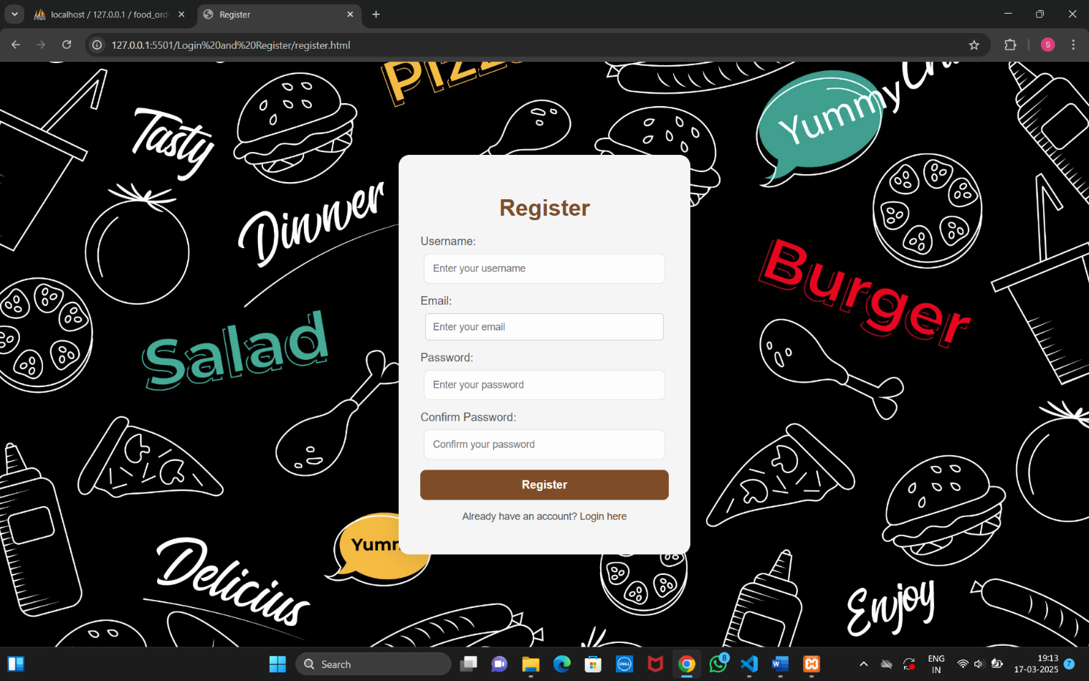

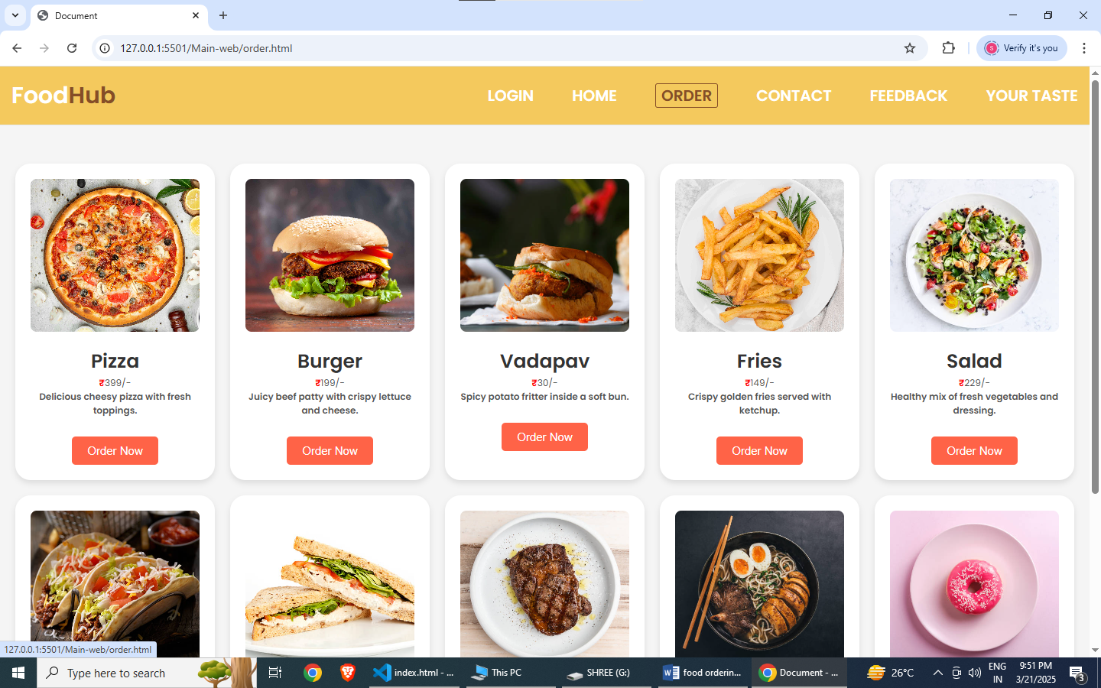**Order**

**Order Details**

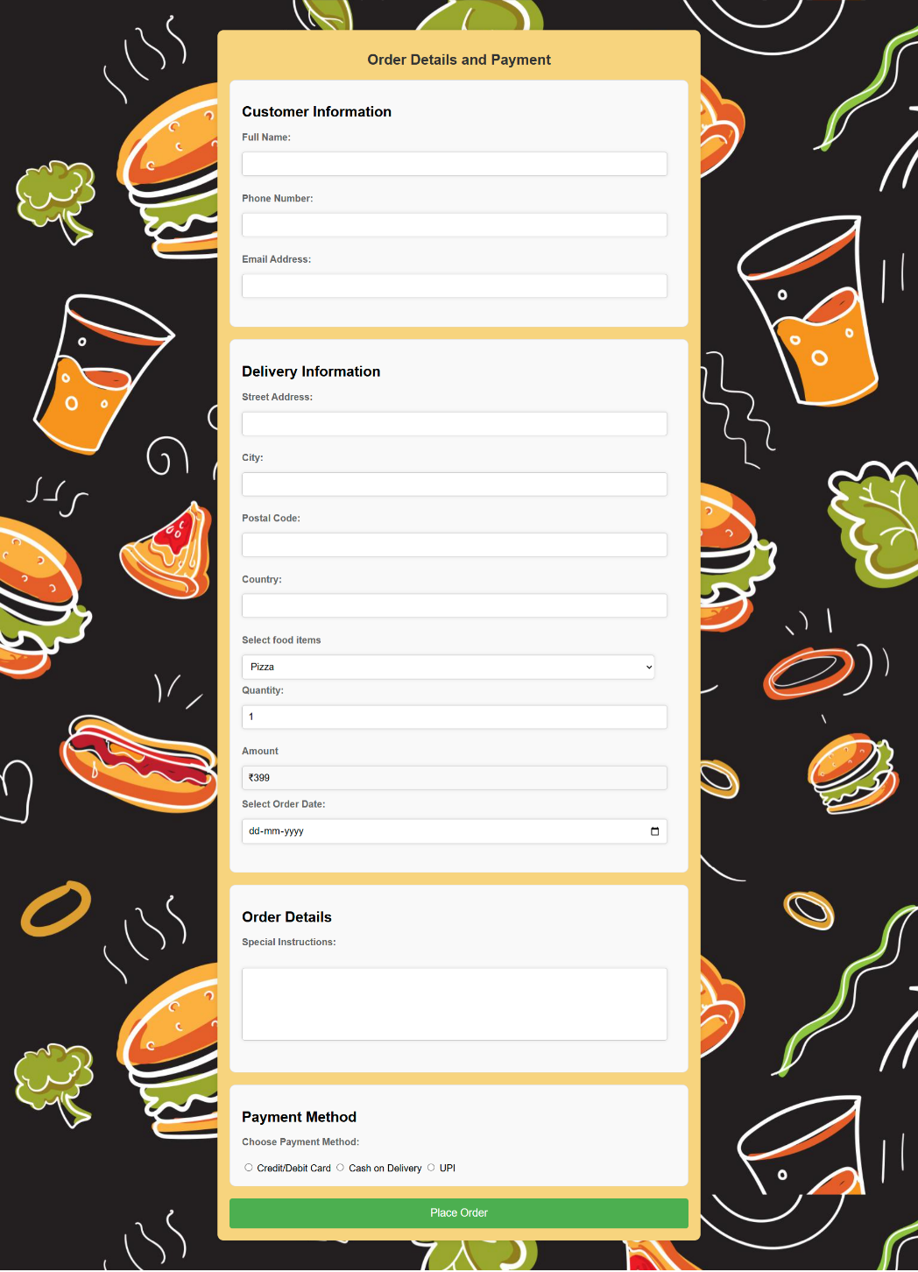

**Contact**

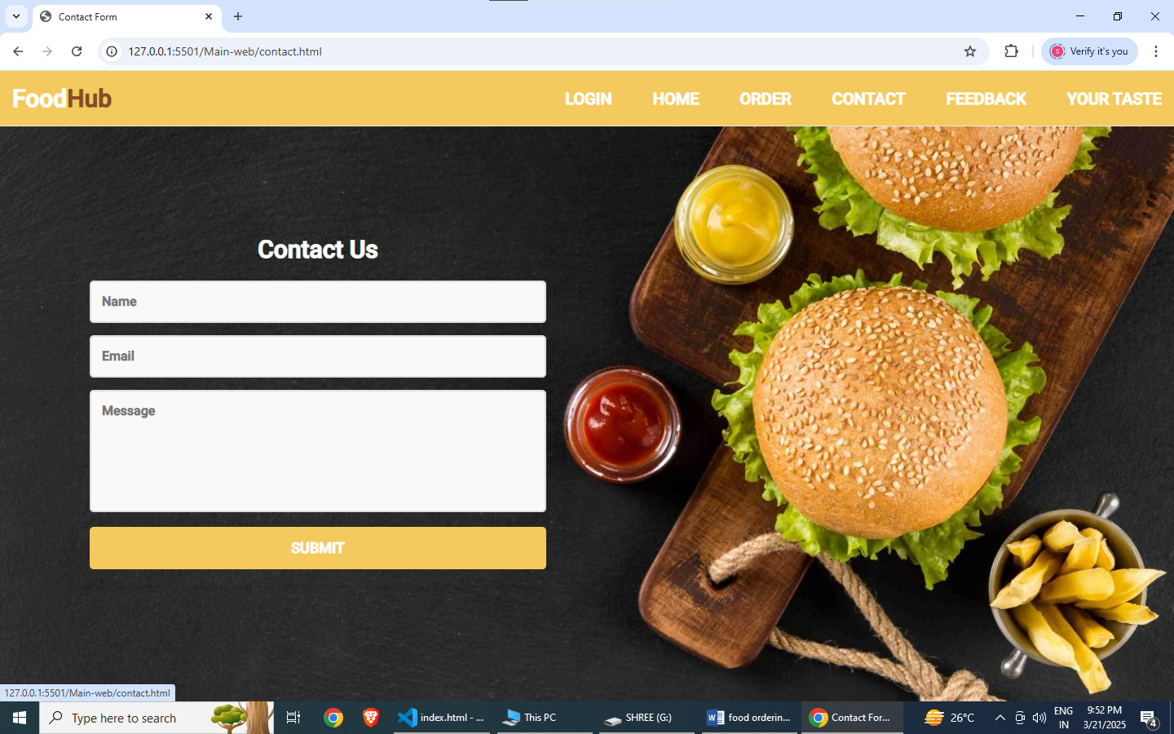

**Feedback**

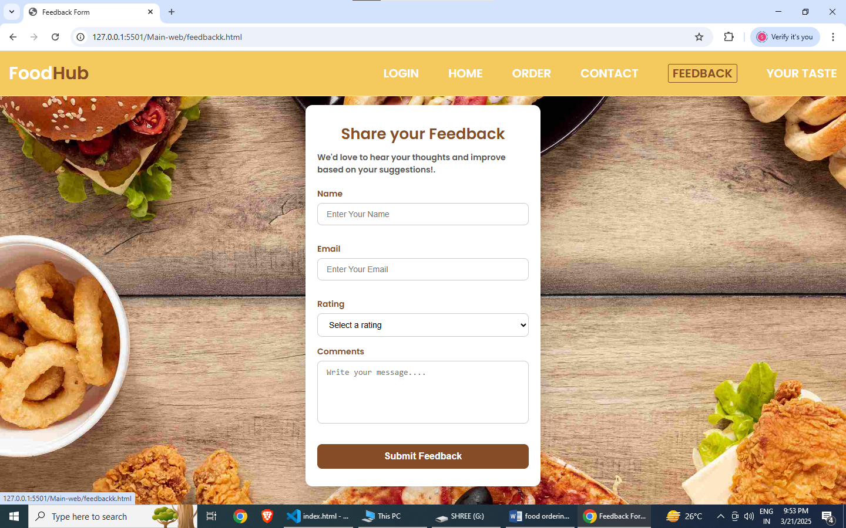

**Your Taste**

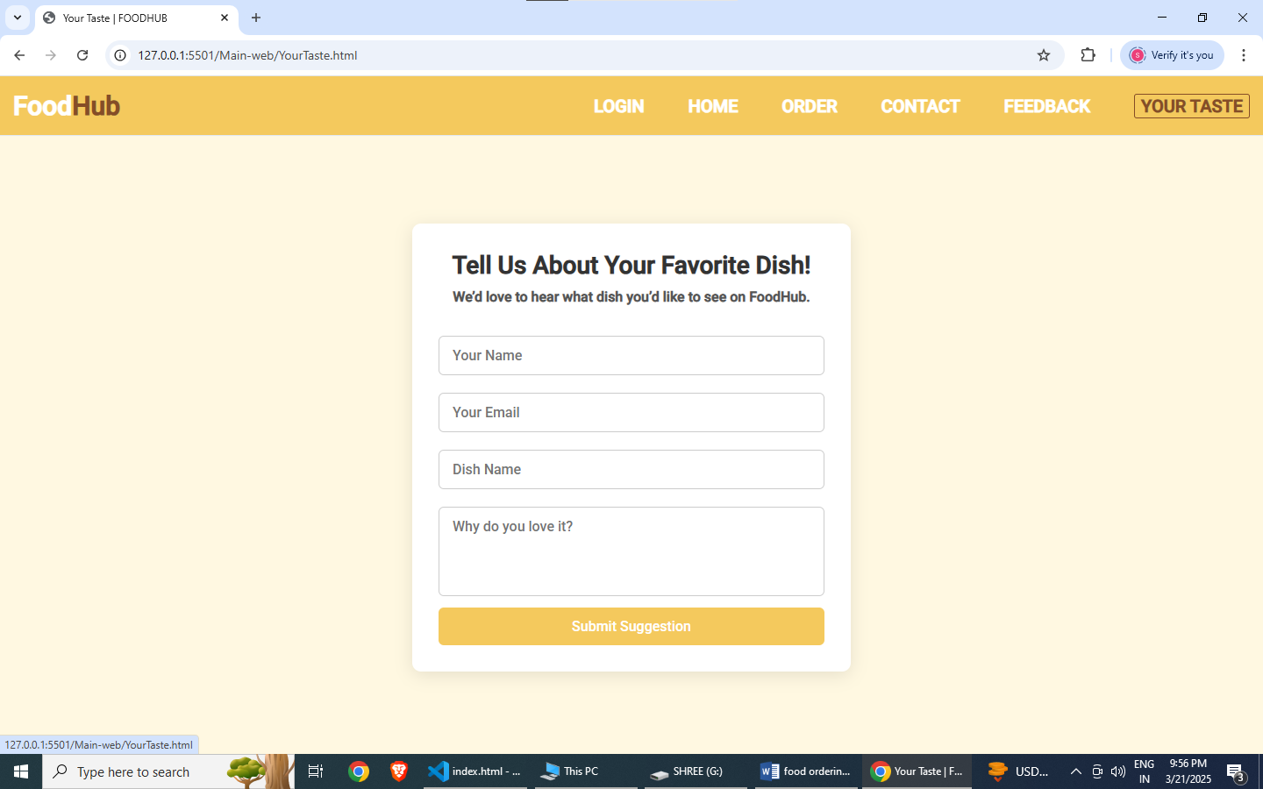

**User Guidelines**

We have three main actors in our **FoodHub** system:

* **Admin**: Responsible for managing orders, viewing contact submissions, user suggestions, feedback, and registered users.
* **User (Customer)**: Can register, log in, browse dishes, place food orders, submit feedback, and suggest new dishes.
* **System**: Automatically stores user interactions, displays them in the admin dashboard, and manages user access.

**Top Use Cases of the FoodHub :**

* **Add/Remove/Manage Orders**: Admin can view and manage customer food orders.
* **Browse Dishes**: Users can explore available dishes before placing an order.
* **Submit Feedback**: Users can provide ratings and feedback for their experience.
* **Suggest a Dish ("Your Taste")**: Users can suggest new dishes via a dedicated form.
* **Register / Login / Logout**: Users can create accounts, securely log in.
* **Contact Submission**: Users can send queries or feedback to the admin.

**Installation Procedure:**

**Setup:**

* Install the software of visual Studio
* Install Xampp Database Software
* Install Node.js

**For User :**

* Install a web browser.
* Ensure internet connectivity.
* Access URL of FoodHub.

**Home Page**

**Index.html**

**Code:**

<!DOCTYPE html>

<html lang="en">

<head>

<meta charset="UTF-8">

<meta http-equiv="X-UA-Compatible" content="IE=edge">

<meta name="viewport" content="width=device-width, initial-scale=1.0">

<title>FOODHUB</title>

<link rel="stylesheet" href="styleee.css">

<link rel="stylesheet" href="https://cdnjs.cloudflare.com/ajax/libs/font-awesome/4.7.0/css/font-awesome.min.css">

<link href="https://cdn.jsdelivr.net/npm/bootstrap@5.3.3/dist/css/bootstrap.min.css">

</head>

<body>

<header class="header">

<nav class="navbar">

<a href="#" class="nav-logo">Food<span style="color:#854d27">Hub</span></a>

<ul class="nav-menu">

<li class="nav-item">

<a href="../Login and Register/login.html" class="nav-link">LogIn</a>

</li>

<li class="nav-item">

<a href="index.html" class="nav-link">Home</a>

</li>

<li class="nav-item">

<a href="order.html" class="nav-link">Order</a>

</li>

<li class="nav-item">

<a href="contact.html" class="nav-link">contact</a>

</li>

<li class="nav-item">

<a href="feedbackk.html" class="nav-link">feedback</a>

</li>

<li class="nav-item">

<a href="YourTaste.html" class="nav-link">Your Taste</a>

</li>

</ul>

<div class="hamburger">

<span class="bar"></span>

<span class="bar"></span>

<span class="bar"></span>

</div>

</nav>

</header>

<!-- Hero Banner Section -->

<section class="hero-banner">

<div class="hero-content">

<h1>Craving Something Tasty? <br>Get Delicious Meals Delivered with Ease!</h1>

<p>Satisfy Your Hunger with Just a Few Clicks</p>

<div class="ord"><a href="order.html" class="cta-button">Order now</a></div>

</div>

</section>

<footer>

<div class="footer-container">

<div class="footer-left">

<h3>FOODHUB</h3>

<p>&copy; 2023 FOODHUB. All rights reserved.</p>

</div>

<div class="footer-center">

<h3>Quick Links</h3>

<ul>

<li><a href="index.html">Home</a></li>

<li><a href="order.html">Order</a></li>

<li><a href="contact.html">Contact Us</a></li>

<li><a href="feedbackk.html">Feedback</a></li>

</ul>

</div>

<div class="footer-right">

<h3>Follow Us</h3>

<ul>

<li><a href="#" target="_blank"><i class="fa fa-facebook"></i></a></li>

<li><a href="#" target="_blank"><i class="fa fa-twitter"></i></a></li>

<li><a href="#" target="_blank"><i class="fa fa-instagram"></i></a></li>

</ul>

</div>

</div>

</footer>

<script src="https://cdn.jsdelivr.net/npm/bootstrap@5.3.3/dist/js/bootstrap.bundle.min.js" integrity="sha384-YvpcrYf0tY3lHB60NNkmXc5s9fDVZLESaAA55NDzOxhy9GkcIdslK1eN7N6jIeHz" crossorigin="anonymous"></script>

</body>

</html>

**Login.html**

**Code:**

<!DOCTYPE html>

<html lang="en">

<head>

<meta charset="UTF-8" />

<meta name="viewport" content="width=device-width, initial-scale=1.0" />

<title>FOODHUB</title>

<link rel="stylesheet" href="index.css" />

</head>

<body>

<div class="form-container" id="loginFormContainer">

<form id="loginForm">

<h2>Login</h2>

<label for="role">Role:</label>

<select id="role" name="role" required>

<option value="users">User</option>

<option value="admin">Admin</option>

</select>

<label for="username">Username:</label>

<input type="text" id="username" name="username" placeholder="Enter your username" required />

<label for="password">Password:</label>

<input type="password" id="password" name="password" placeholder="Enter your password" required />

<button type="submit">Login</button>

<p>

Forgot your password?

<a href="forgot_password.html">Reset here</a>

</p>

<p>

Don't have an account?

<a href="register.html">Register now</a>

</p>

</form>

</div>

<script>

document

.getElementById("loginForm")

.addEventListener("submit", function(e) {

e.preventDefault();

// Pre-populate the username and password fields

const username = document.getElementById("username").value;

const password = document.getElementById("password").value;

const role = document.getElementById("role").value;

const loginData = {

username: document.getElementById("username").value,

password: document.getElementById("password").value,

role: document.getElementById("role").value,

};

console.log("Login Data:", loginData);

if (!loginData.username || !loginData.password) {

alert("All fields are required");

return;

}

fetch("http://localhost:3000/login", {

method: "POST",

headers: {

"Content-Type": "application/json"

},

body: JSON.stringify(loginData),

})

.then((response) => response.json())

.then((data) => {

if (data.success) {

alert(data.message);

if (role === "admin") {

// Redirect to the admin dashboard page

window.location.href = "../Admin/admin_dashboard.html"; // Adjust the path as needed

} else if (role === "users") {

localStorage.setItem("userId", data.testerId);

// Redirect to the tester page (or the main page for testers)

window.location.href = "../Main-web/index.html"; // Adjust the path as needed

}

} else {

alert(data.message);

}

})

.catch((error) => console.error("Error:", error));

});

</script>

</body>

</html>

**register.html**

**Code:**

<!DOCTYPE html>

<html lang="en">

<head>

<meta charset="UTF-8">

<meta name="viewport" content="width=device-width, initial-scale=1.0">

<title>Register</title>

<link rel="stylesheet" href="index.css">

</head>

<body>

<div class="form-container" id="registerFormContainer">

<form id="registerForm">

<h2>Register</h2>

<label for="username">Username:</label>

<input type="text" id="username" name="username" placeholder="Enter your username" required>

<label for="email">Email:</label>

<input type="email" id="email" name="email" placeholder="Enter your email" required>

<label for="password">Password:</label>

<input type="password" id="password" name="password" placeholder="Enter your password" required>

<label for="confirmPassword">Confirm Password:</label>

<input type="password" id="confirmPassword" name="confirmPassword" placeholder="Confirm your password" required>

<button type="submit">Register</button>

<p>Already have an account? <a href="login.html">Login here</a></p>

</form>

</div>

<script>

document.addEventListener('DOMContentLoaded', function() {

document.getElementById('registerForm').addEventListener('submit', function(e) {

e.preventDefault();

const formData = {

email: document.getElementById('email').value,

username: document.getElementById('username').value,

password: document.getElementById('password').value,

confirmPassword: document.getElementById('confirmPassword').value

};

for (let key in formData) {

if (formData[key] === "") {

alert(`${key} is required`);

return; // Exit the function if any field is empty

}

}

if (formData.password !== formData.confirmPassword) {

alert('Passwords do not match');

return;

}

// Remove confirmPassword from the data sent to the server

delete formData.confirmPassword;

console.log('Form data:', formData);

fetch('http://localhost:3000/register', {

method: 'POST',

headers: {

'Content-Type': 'application/json'

},

body: JSON.stringify(formData)

})

.then(response => response.json())

.then(data => {

console.log('Data received:', data);

alert(data.message);

if (data.success) {

window.location.href = 'login.html';

}

})

.catch(error => {

console.error('Error:', error);

});

});

});

</script>

</body>

</html>

**order.html**

**Code:**

<!DOCTYPE html>

<html lang="en">

<head>

<meta charset="UTF-8">

<meta name="viewport" content="width=device-width, initial-scale=1.0">

<link rel="stylesheet" href="order.css">

<title>Document</title>

</head>

<body>

<header class="header">

<nav class="navbar">

<a href="./index.html" class="nav-logo">Food<span style="color:#854d27">Hub</span></a>

<ul class="nav-menu">

<li class="nav-item">

<a href="../Login and Register/login.html" class="nav-link">LogIn</a>

</li>

<li class="nav-item">

<a href="index.html" class="nav-link">Home</a>

</li>

<li class="nav-item">

<a href="order.html" class="nav-link">Order</a>

</li>

<li class="nav-item">

<a href="contact.html" class="nav-link">contact</a>

</li>

<li class="nav-item">

<a href="feedbackk.html" class="nav-link">feedback</a>

</li>

<li class="nav-item"><a href="YourTaste.html" class="nav-link">Your Taste</a></li>

</ul>

<div class="hamburger">

<span class="bar"></span>

<span class="bar"></span>

<span class="bar"></span>

</div>

</nav>

</header>

<section class="menu">

<div class="food-item">

<img src="../img/pizza (1).jpg" alt="Pizza">

<h2>Pizza</h2>

<p><span class="price">&#8377;</span>399/-</p>

<p class="description">Delicious cheesy pizza with fresh toppings.</p>

<button class="order-btn" onclick="orderNow('Pizza')">Order Now</button>

</div>

<div class="food-item">

<img src="../img/burger (1).jpg" alt="Burger">

<h2>Burger</h2>

<p><span class="price">&#8377;</span>199/-</p>

<p class="description">Juicy beef patty with crispy lettuce and cheese.</p>

<button class="order-btn" onclick="orderNow('Burger')">Order Now</button>

</div>

<div class="food-item">

<img src="../img/vada.jpg" alt="Vada">

<h2>Vadapav</h2>

<p><span class="price">&#8377;</span>30/-</p>

<p class="description">Spicy potato fritter inside a soft bun.</p>

<button class="order-btn" onclick="orderNow('Vadapav')">Order Now</button>

</div>

<div class="food-item">

<img src="../img/fris (1).jpg" alt="Fries">

<h2>Fries</h2>

<p><span class="price">&#8377;</span>149/-</p>

<p class="description">Crispy golden fries served with ketchup.</p>

<button class="order-btn" onclick="orderNow('Fries')">Order Now</button>

</div>

<div class="food-item">

<img src="../img/salad.jpg" alt="Salad">

<h2>Salad</h2>

<p><span class="price">&#8377;</span>229/-</p>

<p class="description">Healthy mix of fresh vegetables and dressing.</p>

<button class="order-btn" onclick="orderNow('Salad')">Order Now</button>

</div>

<div class="food-item">

<img src="../img/Taco.jpg" alt="Taco">

<h2>Taco</h2>

<p><span class="price">&#8377;</span>175/-</p>

<p class="description">Crispy taco shell filled with seasoned meat.</p>

<button class="order-btn" onclick="orderNow('Taco')">Order Now</button>

</div>

<div class="food-item">

<img src="../img/sandwich.jpg" alt="Sandwich">

<h2>Sandwich</h2>

<p><span class="price">&#8377;</span>79/-</p>

<p class="description">Freshly made sandwich with layers of flavor.</p>

<button class="order-btn" onclick="orderNow('Sandwich')">Order Now</button>

</div>

<div class="food-item">

<img src="../img/steak.jpg" alt="Steak">

<h2>Steak</h2>

<p><span class="price">&#8377;</span>599/-</p>

<p class="description">Tender, juicy steak grilled to perfection.</p>

<button class="order-btn" onclick="orderNow('Steak')">Order Now</button>

</div>

<div class="food-item">

<img src="../img/ramen.jpg" alt="Ramen">

<h2>Ramen</h2>

<p><span class="price">&#8377;</span>299/-</p>

<p class="description">Hot and flavorful Japanese noodle soup.</p>

<button class="order-btn" onclick="orderNow('Ramen')">Order Now</button>

</div>

<div class="food-item">

<img src="../img/donut.jpg" alt="Donut">

<h2>Donut</h2>

<p><span class="price">&#8377;</span>49/-</p>

<p class="description">Sweet and fluffy donut with chocolate glaze.</p>

<button class="order-btn" onclick="orderNow('Donut')">Order Now</button>

</div>

</section>

<footer>

<p>&copy; 2025 FOODHUB. All rights reserved.</p>

</footer>

<script>

// Get all the "Order Now" buttons

const orderNowButtons = document.querySelectorAll('.order-btn');

// Add event listener to each "Order Now" button

orderNowButtons.forEach(button => {

button.addEventListener('click', () => {

// Redirect the user to the ordDetails page

window.location.href = 'ordDetails.html';

});

});

</script>

</body>

</html>

**orderDetails.html**

</html>

<!DOCTYPE html>

<html lang="en">

<head>

<meta charset="UTF-8">

<meta name="viewport" content="width=device-width, initial-scale=1.0">

<title>Order Details and Payment</title>

<link rel="stylesheet" href="ordDetails.css">

</head>

<body>

<div class="container">

<h1>Order Details and Payment</h1>

<form id="orderForm">

<!-- Customer Information -->

<section>

<h2>Customer Information</h2>

<label for="name">Full Name:</label>

<input type="text" id="name" name="name" required><br><br>

<label for="phone">Phone Number:</label>

<input type="text" id="phone" name="phone" required><br><br>

<label for="email">Email Address:</label>

<input type="email" id="email" name="email" required><br><br>

</section>

<!-- Delivery Information -->

<section>

<h2>Delivery Information</h2>

<label for="address">Street Address:</label>

<input type="text" id="address" name="address" required><br><br>

<label for="city">City:</label>

<input type="text" id="city" name="city" required><br><br>

<label for="postalCode">Postal Code:</label>

<input type="text" id="postalCode" name="postalCode" required><br><br>

<label for="country">Country:</label>

<input type="text" id="country" name="country" required><br><br>

<label for="selectfood">Select food items</label>

<select id="selectfood" name="selectfood">

<option value="pizza">Pizza</option>

<option value="burger">Burger</option>

<option value="vadapav">Vadapav</option>

<option value="fries">Fries</option>

<option value="salad">Salad</option>

<option value="taco">Taco</option>

<option value="sandwich">Sandwich</option>

<option value="steak">Steak</option>

<option value="ramen">Ramen</option>

<option value="donut">Donut</option>

</select>

<div id="quantity-container">

<label for="quantity">Quantity:</label>

<input type="number" id="quantity" name="quantity" value="1" min="1" max="10">

</div>

<br>

<label for="text">Amount</label>

<input type="text" id="amount" name="amount" readonly>

<label for="orderDate">Select Order Date:</label>

<input type="date" id="orderDate" name="orderDate" required><br><br>

</section>

<!-- Order Details -->

<section>

<h2>Order Details</h2>

<label for="specialInstructions">Special Instructions:</label><br>

<textarea id="specialInstructions" name="specialInstructions" style="height: 100px; resize: none;"></textarea><br><br>

</section>

<!-- Payment Method -->

<section>

<h2>Payment Method</h2>

<label for="paymentMethod">Choose Payment Method:</label><br>

<input type="radio" id="creditCard" name="paymentMethod" value="Credit/Debit Card" required> Credit/Debit Card

<div id="creditCardDetails" style="display: none;">

<label for="cardNumber">Credit/Debit Card Number:</label>

<input type="text" id="cardNumber" name="cardNumber" placeholder="Enter your card number" required>

<label for="cardExpiry">Card Expiry:</label>

<input type="text" id="cardExpiry" name="cardExpiry" placeholder="MM/YY" required>

<label for="cardCvv">Card CVV:</label>

<input type="text" id="cardCvv" name="cardCvv" placeholder="Enter your card CVV" required>

</div>

<input type="radio" id="cash" name="paymentMethod" value="Cash on Delivery" required> Cash on Delivery

<input type="radio" id="upi" name="paymentMethod" value="UPI" required> UPI

<div id="upiDetails" style="display: none;">

<label for="upiMethod">Select UPI Method:</label><br>

<div style="display: flex; flex-direction: row;">

<input type="radio" id="googlePay" name="upiMethod" value="Google Pay" required> Google Pay

<input type="radio" id="phonePay" name="upiMethod" value="Phone Pay" required> Phone Pay

<input type="radio" id="upiId" name="upiMethod" value="UPI ID" required> UPI ID

</div>

<div id="upiIdInput" style="display: none;">

<label for="upiIdValue">Enter UPI ID:</label>

<input type="text" id="upiIdValue" name="upiIdValue" placeholder="Enter your UPI ID" required>

</div>

</div>

</section>

<button type="submit">Place Order</button>

</form>

</div>

<script>

// Get the credit card radio button

const creditCardRadio = document.getElementById('creditCard');

// Add event listener to the credit card radio button

creditCardRadio.addEventListener('change', () => {

const creditCardDetails = document.getElementById('creditCardDetails');

if (creditCardRadio.checked) {

creditCardDetails.style.display = 'block';

} else {

creditCardDetails.style.display = 'none';

document.getElementById('cardNumber').value = '';

document.getElementById('cardExpiry').value = '';

document.getElementById('cardCvv').value = '';

}

});

// Get the UPI radio button

const upiRadio = document.getElementById('upi');

// Add event listener to the UPI radio button

upiRadio.addEventListener('change', () => {

const upiDetails = document.getElementById('upiDetails');

if (upiRadio.checked) {

upiDetails.style.display = 'block';

} else {

upiDetails.style.display = 'none';

}

});

// Get the UPI ID radio button

const upiIdRadio = document.getElementById('upiId');

// Add event listener to the UPI ID radio button

upiIdRadio.addEventListener('change', () => {

const upiIdInput = document.getElementById('upiIdInput');

if (upiIdRadio.checked) {

upiIdInput.style.display = 'block';

} else {

upiIdInput.style.display = 'none';

}

});

// Get the order form

const orderForm = document.getElementById('orderForm');

// Add event listener to the form submission

orderForm.addEventListener('submit', (e) => {

e.preventDefault();

// Get the selected food item, quantity, and order date

const selectedFood = document.getElementById('selectfood').value;

const quantity = document.getElementById('quantity').value;

const orderDate = document.getElementById('orderDate').value;

const name = document.getElementById('name').value;

const phone = document.getElementById('phone').value;

const email = document.getElementById('email').value;

const address = document.getElementById('address').value;

const city = document.getElementById('city').value;

const postalCode = document.getElementById('postalCode').value;

const country = document.getElementById('country').value;

const specialInstructions = document.getElementById('specialInstructions').value;

const paymentMethod = document.querySelector('input[name="paymentMethod"]:checked').value;

// Create a new object to store the order details

const orderDetails = {

name: name,

phone: phone,

email: email,

address: address,

city: city,

postalCode: postalCode,

country: country,

foodItem: selectedFood,

quantity: quantity,

amount: document.getElementById('amount').value,

orderDate: orderDate,

specialInstructions: specialInstructions,

paymentMethod: paymentMethod

};

// Send the order details to the server

fetch('http://localhost:3000/place-order', {

method: 'POST',

headers: {

'Content-Type': 'application/json'

},

body: JSON.stringify(orderDetails)

})

.then(response => response.json())

.then(data => {

console.log('Order placed successfully:', data);

alert('Order placed successfully!');

orderForm.reset();

})

.catch(error => {

console.error('Error placing order:', error);

alert('Error placing order. Please try again later.');

});

});

// Define the prices for each food item

const prices = {

pizza: 399,

burger: 199,

vadapav: 30,

fries: 149,

salad: 229,

taco: 175,

sandwich: 79,

steak: 599,

ramen: 299,

donut: 49

};

// Get the select food item, quantity, and amount fields

const selectFood = document.getElementById('selectfood');

const quantity = document.getElementById('quantity');

const amount = document.getElementById('amount');

// Add an event listener to the select food item field

selectFood.addEventListener('change', calculateAmount);

// Add an event listener to the quantity field

quantity.addEventListener('input', calculateAmount);

// Function to calculate the amount

function calculateAmount() {

const selectedFood = selectFood.value;

const quantityValue = parseInt(quantity.value);

const price = prices[selectedFood];

const calculatedAmount = price * quantityValue;

amount.value = `₹${calculatedAmount}`;

}

// Call the calculateAmount function initially

calculateAmount();

// Function to toggle credit card fields

function toggleCreditCardFields() {

const creditCardDetails = document.getElementById('creditCardDetails');

if (document.getElementById('creditCard').checked) {

creditCardDetails.style.display = 'block';

document.getElementById('cardNumber').setAttribute('required', 'true');

document.getElementById('cardExpiry').setAttribute('required', 'true');

document.getElementById('cardCvv').setAttribute('required', 'true');

} else {

creditCardDetails.style.display = 'none';

document.getElementById('cardNumber').removeAttribute('required');

document.getElementById('cardExpiry').removeAttribute('required');

document.getElementById('cardCvv').removeAttribute('required');

}

}

// Function to toggle UPI fields

function toggleUPIFields() {

const upiDetails = document.getElementById('upiDetails');

if (document.getElementById('upi').checked) {

upiDetails.style.display = 'block';

} else {

upiDetails.style.display = 'none';

document.querySelectorAll('input[name="upiMethod"]').forEach((input) => input.removeAttribute('required'));

document.getElementById('upiIdValue').removeAttribute('required');

}

}

// Function to toggle UPI ID input field

function toggleUPIIdField() {

const upiIdInput = document.getElementById('upiIdInput');

if (document.getElementById('upiId').checked) {

upiIdInput.style.display = 'block';

document.getElementById('upiIdValue').setAttribute('required', 'true');

} else {

upiIdInput.style.display = 'none';

document.getElementById('upiIdValue').removeAttribute('required');

}

}

// Add event listeners

document.getElementById('creditCard').addEventListener('change', toggleCreditCardFields);

document.getElementById('upi').addEventListener('change', toggleUPIFields);

document.getElementById('upiId').addEventListener('change', toggleUPIIdField);

// Run functions on page load to ensure proper state

toggleCreditCardFields();

toggleUPIFields();

toggleUPIIdField();

// Modify form submission to prevent errors

document.getElementById('orderForm').addEventListener('submit', function(e) {

toggleCreditCardFields();

toggleUPIFields();

toggleUPIIdField();

});

document.addEventListener("DOMContentLoaded", () => {

const orderForm = document.getElementById("orderForm");

function generateReceipt(orderDetails) {

const {

jsPDF

} = window.jspdf;

const doc = new jsPDF();

doc.setFont("helvetica", "bold");

doc.setFontSize(18);

doc.text("FoodHub - Order Receipt", 20, 20);

doc.setFontSize(12);

doc.setFont("helvetica", "normal");

doc.text(`Customer Name: ${orderDetails.name}`, 20, 40);

doc.text(`Phone: ${orderDetails.phone}`, 20, 50);

doc.text(`Email: ${orderDetails.email}`, 20, 60);

doc.text(`Address: ${orderDetails.address}, ${orderDetails.city}, ${orderDetails.country}`, 20, 70);

doc.text(`Postal Code: ${orderDetails.postalCode}`, 20, 80);

doc.text(`Food Item: ${orderDetails.foodItem}`, 20, 100);

doc.text(`Quantity: ${orderDetails.quantity}`, 20, 110);

doc.text(`Amount: ${orderDetails.amount}`, 20, 120);

doc.text(`Order Date: ${orderDetails.orderDate}`, 20, 130);

doc.text(`Payment Method: ${orderDetails.paymentMethod}`, 20, 150);

if (orderDetails.specialInstructions) {

doc.text(`Special Instructions: ${orderDetails.specialInstructions}`, 20, 170);

}

doc.text("Thank you for your order!", 20, 190);

doc.save(`Order_Receipt_${Date.now()}.pdf`);

}

orderForm.addEventListener("submit", (e) => {

e.preventDefault();

// Get order details

const selectedFood = document.getElementById("selectfood").value;

const quantity = document.getElementById("quantity").value;

const orderDate = document.getElementById("orderDate").value;

const name = document.getElementById("name").value;

const phone = document.getElementById("phone").value;

const email = document.getElementById("email").value;

const address = document.getElementById("address").value;

const city = document.getElementById("city").value;

const postalCode = document.getElementById("postalCode").value;

const country = document.getElementById("country").value;

const specialInstructions = document.getElementById("specialInstructions").value;

const paymentMethod = document.querySelector('input[name="paymentMethod"]:checked').value;

const orderDetails = {

name,

phone,

email,

address,

city,

postalCode,

country,

foodItem: selectedFood,

quantity,

amount: document.getElementById("amount").value,

orderDate,

specialInstructions,

paymentMethod

};

// Send data to the server (optional)

fetch("http://localhost:3000/place-order", {

method: "POST",

headers: {

"Content-Type": "application/json",

},

body: JSON.stringify(orderDetails),

})

.then((response) => response.json())

.then((data) => {

console.log("Order placed successfully:", data);

alert("Order placed successfully!");

orderForm.reset();

generateReceipt(orderDetails); // Generate and download receipt

})

.catch((error) => {

console.error("Error placing order:", error);

alert("Error placing order. Please try again later.");

});

});

});

</script>

<script src="https://cdnjs.cloudflare.com/ajax/libs/jspdf/2.5.1/jspdf.umd.min.js"></script>

</body>

</html>

**contact.html**

<!DOCTYPE html>

<html lang="en">

<head>

<meta charset="UTF-8">

<meta name="viewport" content="width=device-width, initial-scale=1.0">

<title>Contact Form</title>

<link rel="stylesheet" href="styleee.css" />

<link rel="stylesheet" href="contact.css" />

<link rel="stylesheet" href="https://cdnjs.cloudflare.com/ajax/libs/font-awesome/4.7.0/css/font-awesome.min.css">

<link href="https://cdn.jsdelivr.net/npm/bootstrap@5.3.3/dist/css/bootstrap.min.css">

</head>

<body>

<header class="header">

<nav class="navbar">

<a href="./index.html" class="nav-logo">Food<span style="color:#854d27">Hub</span></a>

<ul class="nav-menu">

<li class="nav-item">

<a href="../Login and Register/login.html" class="nav-link">LogIn</a>

</li>

<li class="nav-item">

<a href="index.html" class="nav-link">Home</a>

</li>

<li class="nav-item">

<a href="order.html" class="nav-link">Order</a>

</li>

<li class="nav-item">

<a href="contact.html" class="nav-link">Contact</a>

</li>

<li class="nav-item">

<a href="feedbackk.html" class="nav-link">Feedback</a>

</li>

<li class="nav-item"><a href="YourTaste.html" class="nav-link">Your Taste</a></li>

</ul>

<div class="hamburger">

<span class="bar"></span>

<span class="bar"></span>

<span class="bar"></span>

</div>

</nav>

</header>

<main>

<div class="contact-container">

<h1>Contact Us</h1>

<div id="responseMessage"></div>

<!-- Display API response message -->

<form id="contactForm">

<input name="name" type="text" id="name" class="feedback-input" placeholder="Name" required />

<input name="email" type="email" id="email" class="feedback-input" placeholder="Email" required />

<textarea name="message" id="message" class="feedback-input" placeholder="Message" required></textarea>

<input type="submit" value="SUBMIT" />

</form>

</div>

</main>

<script src="https://cdn.jsdelivr.net/npm/bootstrap@5.3.3/dist/js/bootstrap.bundle.min.js" integrity="sha384-YvpcrYf0tY3lHB60NNkmXc5s9fDVZLESaAA55NDzOxhy9GkcIdslK1eN7N6jIeHz" crossorigin="anonymous"></script>

<script>

document.addEventListener("DOMContentLoaded", function() {

const contactForm = document.getElementById("contactForm");

const responseMessage = document.getElementById("responseMessage");

contactForm.addEventListener("submit", function(event) {

event.preventDefault();

const name = document.getElementById('name').value;

const email = document.getElementById('email').value;

const message = document.getElementById('message').value;

// const formData = new FormData(contactForm);

const formData = {

name: name,

email: email,

message: message,

};

const apiEndpoint = "http://localhost:3000/api/contact";

fetch(apiEndpoint, {

method: "POST",

headers: {

'Content-Type': 'application/json;charset=utf-8'

},

body: JSON.stringify(formData)

})

.then(response => response.json())

.then(data => {

responseMessage.innerHTML = `<p>${data.message}</p>`;

responseMessage.classList.add("success", "show"); // Add 'show' class to make the message visible

setTimeout(() => {

contactForm.reset();

responseMessage.innerHTML = "";

responseMessage.classList.remove("success", "show");

}, 2000);

})

.catch(error => {

console.error("Error:", error);

responseMessage.innerHTML = `<p>Error submitting the form. Please try again later.</p>`;

responseMessage.classList.add("error", "show"); // Add 'show' class to make the message visible

setTimeout(() => {

responseMessage.innerHTML = "";

responseMessage.classList.remove("error", "show");

}, 3000);

});

});

});

</script>

</body>

</html>

**feedbackk.html**

<!DOCTYPE html>

<html lang="en">

<head>

<meta charset="UTF-8">

<meta name="viewport" content="width=device-width, initial-scale=1.0">

<title>Feedback Form</title>

<link rel="stylesheet" href="feedbackk.css">

<link rel="stylesheet" href="styleee.css">

<link href="https://fonts.googleapis.com/css2?family=Poppins:wght@300;400;600&display=swap" rel="stylesheet">

<link rel="stylesheet" href="https://cdnjs.cloudflare.com/ajax/libs/font-awesome/6.0.0-beta3/css/all.min.css">

</head>

<body>

<header class="header">

<nav class="navbar">

<a href="./index.html" class="nav-logo">Food<span style="color:#854d27">Hub</span></a>

<ul class="nav-menu">

<li class="nav-item">

<a href="../Login and Register/login.html" class="nav-link">LogIn</a>

</li>

<li class="nav-item">

<a href="index.html" class="nav-link">Home</a>

</li>

<li class="nav-item">

<a href="order.html" class="nav-link">Order</a>

</li>

<li class="nav-item">

<a href="contact.html" class="nav-link">contact</a>

</li>

<li class="nav-item">

<a href="feedbackk.html" class="nav-link">feedback</a>

</li>

<li class="nav-item"><a href="YourTaste.html" class="nav-link">Your Taste</a></li>

</ul>

<div class="hamburger">

<span class="bar"></span>

<span class="bar"></span>

<span class="bar"></span>

</div>

</nav>

</header>

<!-- fd -->

<div class="feedback-container">

<h1>Share your Feedback</h1>

<p>We'd love to hear your thoughts and improve based on your suggestions!.</p>

<form action="process_feedback.php" method="POST" class="feedback-form">

<div class="form-group">

<label for="name">Name</label>

<input type="text" name="name" id="name" placeholder="Enter Your Name" required>

</div>

<div class="form-group">

<label for="email">Email</label>

<input type="email" name="email" id="email" placeholder="Enter Your Email" required>

</div>

<div class="form-group">

<label for="rating"></i>Rating</label>

<select name="rating" id="rating" required>

<option value="" disabled selected>Select a rating</option>

<option value="Excellent">Excellent</option>

<option value="Good">Good</option>

<option value="Average">Average</option>

<option value="Poor">Poor</option>

<option value="Terrible">Terrible</option>

</select>

</div>

<div class="form-group">

<label for="comments">Comments</label>

<textarea name="comments" id="comments" placeholder="Write your message...." rows="5" required></textarea>

</div>

<button type="submit" class="btn">Submit Feedback</button>

</form>

</div>

<script>

// Get the feedback form

const feedbackForm = document.querySelector(".feedback-form");

// Add an event listener for form submission

feedbackForm.addEventListener("submit", (e) => {

e.preventDefault();

// Collect form data

const name = document.getElementById("name").value;

const email = document.getElementById("email").value;

const rating = document.getElementById("rating").value;

const comments = document.getElementById("comments").value;

// Prepare data to send

const feedbackData = {

name,

email,

rating,

comments

};

// Send data to the server

fetch("http://localhost:3000/api/submitFeedback", {

method: "POST",

headers: {

"Content-Type": "application/json",

},

body: JSON.stringify(feedbackData),

})

.then((response) => response.json())

.then((data) => {

if (data.success) {

alert(data.message);

feedbackForm.reset(); // Clear form fields

} else {

alert("Error: " + data.message);

}

})

.catch((error) => console.error("Error:", error));

});

</script>

</body>

</html>

**YoueTaste.html**

<!DOCTYPE html>

<html lang="en">

<head>

<meta charset="UTF-8">

<meta http-equiv="X-UA-Compatible" content="IE=edge">

<meta name="viewport" content="width=device-width, initial-scale=1.0">

<title>Your Taste | FOODHUB</title>

<link rel="stylesheet" href="yourtaste.css">

<link rel="stylesheet" href="https://cdnjs.cloudflare.com/ajax/libs/font-awesome/4.7.0/css/font-awesome.min.css">

<link rel="stylesheet" href="https://cdnjs.cloudflare.com/ajax/libs/font-awesome/6.5.0/css/all.min.css">

</head>

<body>

<!-- ✅ Navbar Start -->

<header class="header">

<nav class="navbar">

<a href="#" class="nav-logo">Food<span style="color:#854d27">Hub</span></a>

<ul class="nav-menu">

<li class="nav-item"><a href="../Login and Register/login.html" class="nav-link">LogIn</a></li>

<li class="nav-item"><a href="index.html" class="nav-link">Home</a></li>

<li class="nav-item"><a href="order.html" class="nav-link">Order</a></li>

<li class="nav-item"><a href="contact.html" class="nav-link">Contact</a></li>

<li class="nav-item"><a href="feedbackk.html" class="nav-link">Feedback</a></li>

<li class="nav-item"><a href="YourTaste.html" class="nav-link">Your Taste</a></li>

</ul>

<div class="hamburger">

<span class="bar"></span>

<span class="bar"></span>

<span class="bar"></span>

</div>

</nav>

</header>

<!-- ✅ Navbar End -->

<!-- ✅ Suggestion Form Start -->

<section class="taste-form-container">

<h2>Tell Us About Your Favorite Dish!</h2>

<p>We’d love to hear what dish you’d like to see on FoodHub.</p>

<form id="tasteForm">

<input type="text" id="name" placeholder="Your Name" required>

<input type="email" id="email" placeholder="Your Email" required>

<input type="text" id="dishName" placeholder="Dish Name" required>

<textarea id="dishDescription" rows="4" placeholder="Why do you love it?" required></textarea>

<button type="submit">Submit Suggestion</button>

</form>

<div id="success-message" style="display:none; margin-top: 15px; color: green;">

✅ Thank you! Your suggestion has been submitted. 🍽️

</div>

</section>

<!-- ✅ Suggestion Form End -->

<!-- ✅ Script for Form Handling -->

<script>

document.getElementById("tasteForm").addEventListener("submit", async function(event) {

event.preventDefault();

const name = document.getElementById("name").value;

const email = document.getElementById("email").value;

const dishName = document.getElementById("dishName").value;

const dishDescription = document.getElementById("dishDescription").value;

try {

const res = await fetch("http://localhost:3000/suggest-dish", {

method: "POST",

headers: {

"Content-Type": "application/json",

},

body: JSON.stringify({

name,

email,

dishName,

dishDescription,

}),

});

if (res.ok) {

document.getElementById("tasteForm").reset();

const messageDiv = document.getElementById("success-message");

messageDiv.classList.add("show"); // Add class to fade in

messageDiv.style.display = "block";

// Hide the message after 3 seconds

setTimeout(() => {

messageDiv.classList.remove("show"); // Remove fade-in class

messageDiv.style.display = "none";

}, 3000);

} else {

alert("❌ Failed to submit your suggestion. Please try again.");

}

} catch (error) {

console.error("Error:", error);

alert("⚠️ An error occurred. Please check your internet or server.");

}

});

</script>

</body>

</html>

**Reports:**

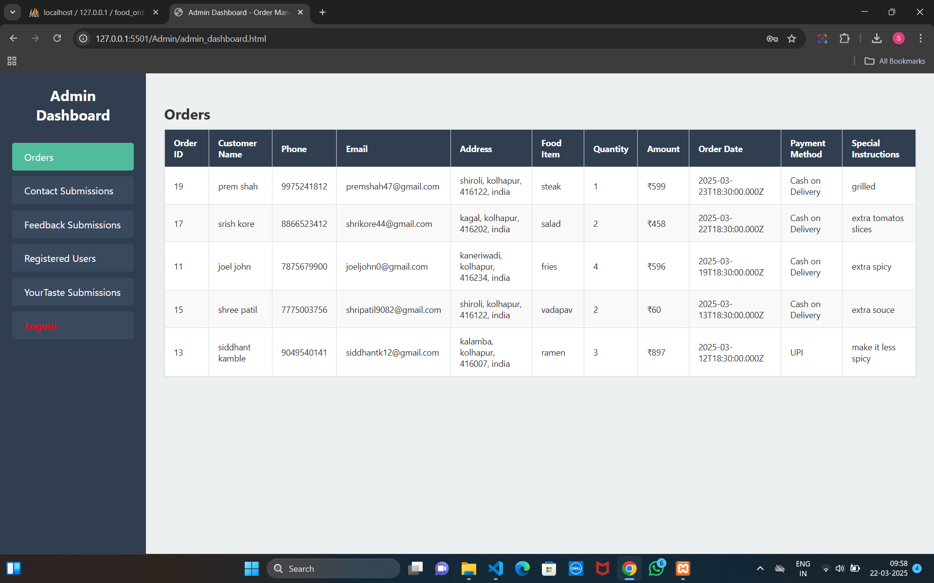**order**

**Contact**

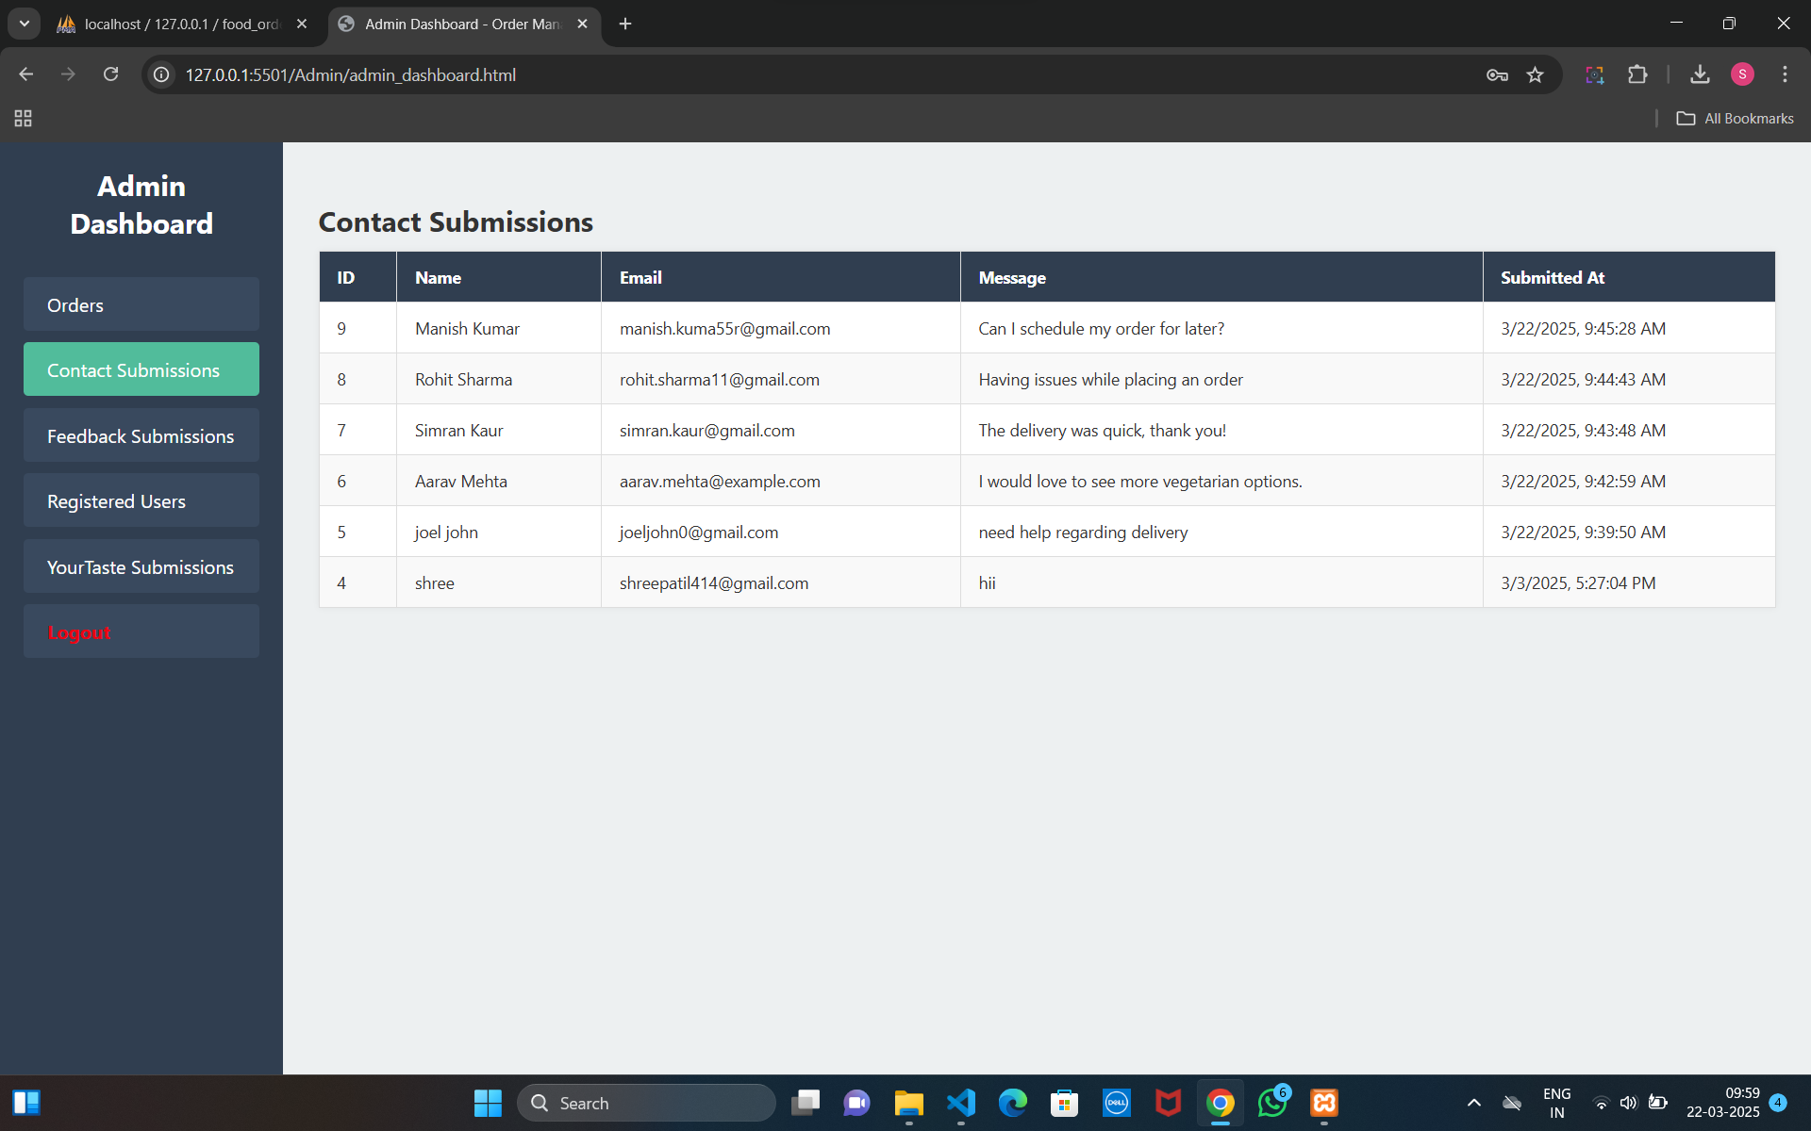

**Feedback**

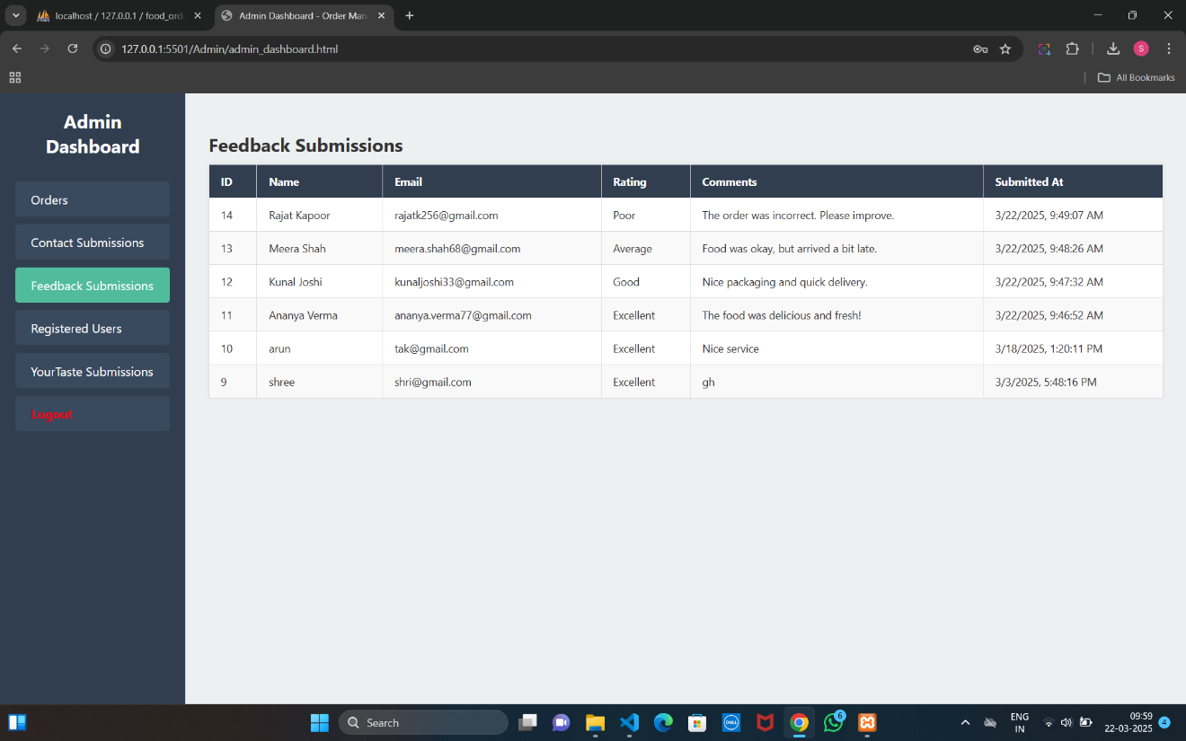

**Registered Users**

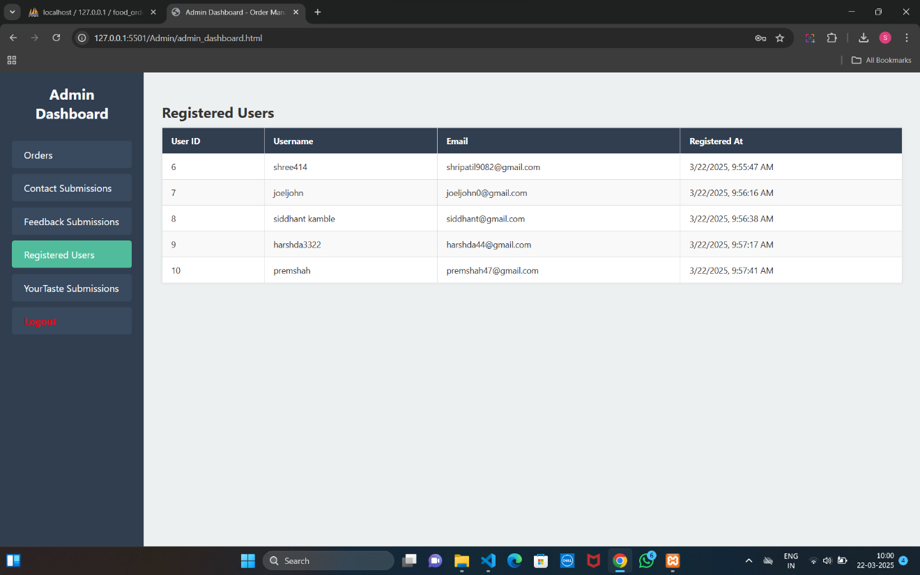

**Your Taste**

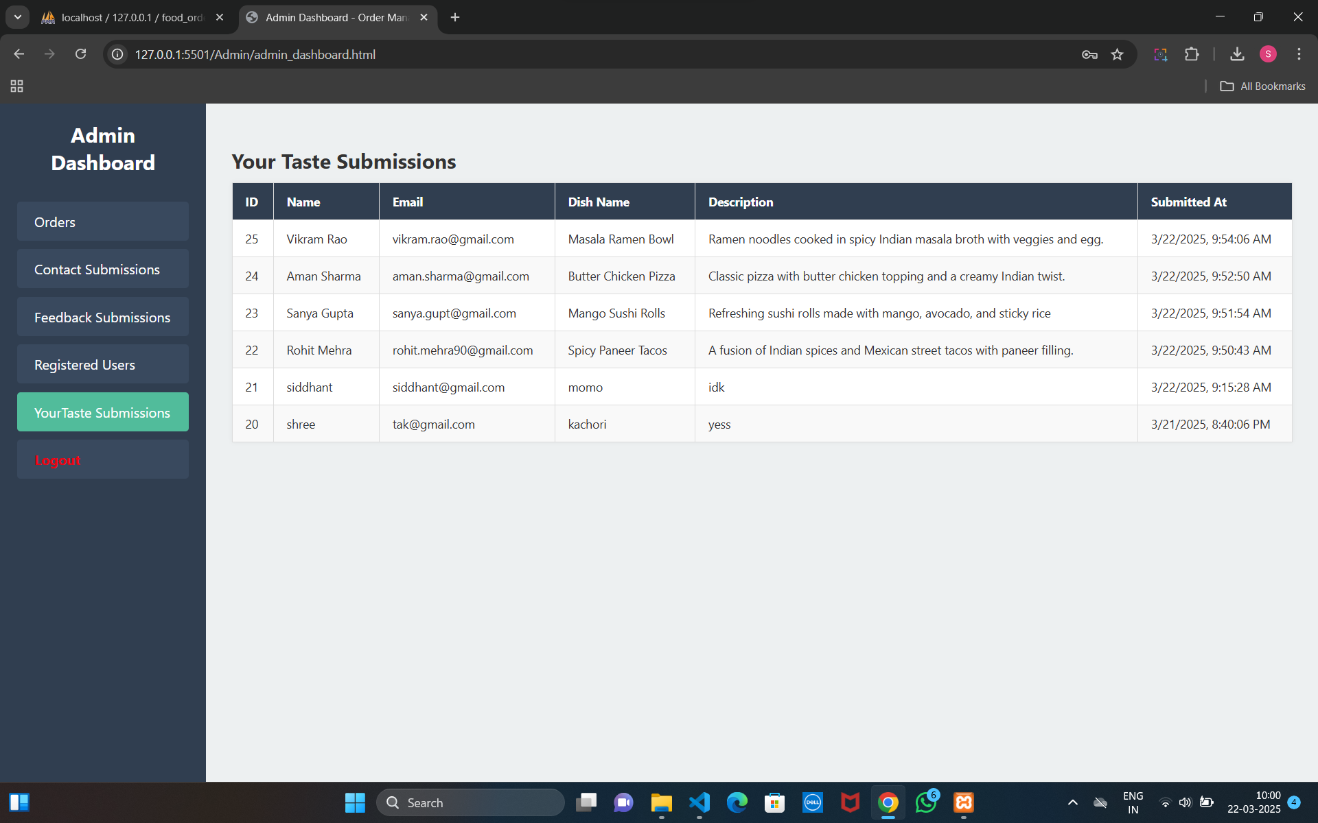

**Conclusion**

This project successfully fulfills its goal of providing an efficient and user-friendly online food ordering platform. By digitizing the food ordering process, it reduces manual work, improves customer convenience, and streamlines restaurant management. The platform allows users to register, log in, browse menu items, place orders, give feedback, and suggest dishes—all through a simple and responsive web interface.

From the backend perspective, the system is built using Node.js and MySQL, ensuring robust data handling and secure server-side processing. Admins are provided with a dedicated dashboard to monitor orders, manage customer interactions, and view feedback and suggestions. This organized system improves business operations and allows better decision-making based on customer input.

Overall, FoodHub bridges the gap between food providers and customers by offering a centralized, reliable, and scalable solution. It not only enhances the user experience but also equips the management with tools to handle everyday tasks efficiently. With further enhancements like payment integration and order tracking, the platform holds great potential for future growth.

**SUGGESTION**

* **Order Tracking Feature**: Adding real-time order tracking can boost transparency and trust. Users should be able to view the order status—whether it’s being prepared, out for delivery, or delivered.
* **Admin Analytics Dashboard**: Enhance the admin panel with visual charts and analytics to monitor sales trends, popular dishes, user activity, and feedback stats. This will help admins make informed decisions.
* **Personalized Recommendations**: Use customer order history and feedback to suggest dishes tailored to their taste. Implementing this can increase engagement and repeat orders.
* **Email Notifications**: Send automated confirmation emails for orders, account creation, and feedback submissions. This improves communication and adds a professional touch to the platform.
* **User Profile & Order History**: Allow users to view and manage their profiles, including their previous orders, favorite dishes, and saved addresses. This not only enhances user experience but also encourages repeat orders.

**Future Enhancements**

* **Mobile Application Development**: Create Android and iOS apps for easier access and improved user convenience.
* **Real-Time Order Tracking**: Enable users to track their orders live from preparation to delivery.
* **AI-Based Recommendations**: Suggest dishes based on users’ previous orders and preferences for a personalized experience.
* **Multilingual Support**: Add multiple language options to cater to users from diverse backgrounds.
* **Rewards and Loyalty Program**: Introduce incentives like discounts or points to retain and encourage repeat customers.

**Websites:**

* [www.Google.com](http://www.Google.com)
* [www.YouTube.com](http://www.YouTube.com)
* [www.chatgpt.com](http://www.chatgpt.com)
* [www.blackbox.com](http://www.blackbox.com)